INDEX

Sl No | Name of the program | Date | Page No | Remarks
1 | Create your class time table using table tag. |  | 2
2 | Design a Webpage for your college containing description of courses, department, faculties, library etc. using list tags, href tags, and anchor tags.

Program 1

Aim

Create your class time table using table tag.

Program
<!DOCTYPE html>
<html>
<head>
<title>Time Table</title>
</head>
<body>
<table border="8">
<caption>
<details>
<summary>TIME TABLE</summary>
<p>This table provides the time table of second semester BCA at SGC Aruvithura</p>
</details>
</caption>
<tr>
<th></th>
<th>Hour 1</th>
<th>Hour 2</th>
<th>Hour 3</th>
<th>Hour 4</th>
<th>Hour 5</th>
</tr>
<tr>
<th>Day 1</th>
<td>Ds</td>
<td>OS</td>
<td>IC</td>
<td>WT</td>
<td>WT</td>
</tr>
<tr>
<th>Day 2</th>
<td>Hindi/Malayalam</td>
<td>DS</td>
<td>OS</td>
<td>Maths</td>
<td>Maths</td>
</tr>
<tr>
<th>Day 3</th>
<td>DS</td>
<td>English</td>
<td>Hindi/Malayalam</td>
<td>WT</td>
<td>OS</td>
</tr>
<tr>
<th>Day 4</th>
<td>OS</td>
<td>Maths</td>
<td>IC</td>
<td>English</td>
<td>Hindi/Malayalam</td>
</tr>
<tr>
<th>Day 5</th>
<td>DS</td>
<td>Maths</td>
<td>English</td>
<td>DS</td>
<td>DS</ts>
</tr>
</table>
</body>
</html>
Output

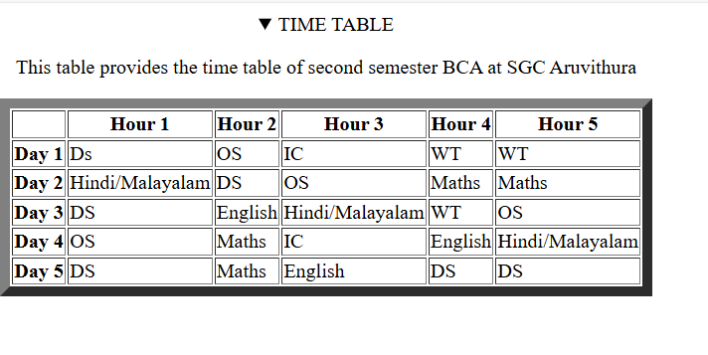

Program 2

Aim
Design a Webpage for your college containing description of courses, department, faculties, library etc. using list tags, href tags, and anchor tags.

Program

Output

Program 3

Aim

Create Your Resume using HTML.Use text, link, and lists.

Program

Output

Program 4

Aim

Create a Web Page of a supermarket using(internal CSS).

Program

Output

Program 5

Aim

Use Inline CSS to format your resume that you have created.

Program

Output

Program 6
Aim

Use External CSS to format your time table created.

Program

<!DOCTYPE html>
<html>
<head>
<title>Time Table</title>
<link rel="stylesheet" href="pgm6.css">
</head>
<body>
<table border="8">
<caption>
<details>
<summary>TIME TABLE</summary>
<p>This table provides the time table of second semester BCA at SGC Aruvithura</p>
</details>
</caption>
<tr>
<th></th>
<th>Hour 1</th>
<th>Hour 2</th>
<th>Hour 3</th>
<th>Hour 4</th>
<th>Hour 5</th>
</tr>
<tr>
<th>Day 1</th>
<td>Ds</td>
<td>OS</td>
<td>IC</td>
<td>WT</td>
<td>WT</td>
</tr>
<tr>
<th>Day 2</th>
<td>Hindi/Malayalam</td>
<td>DS</td>
<td>OS</td>
<td>Maths</td>
<td>Maths</td>
</tr>
<tr>
<th>Day 3</th>
<td>DS</td>
<td>English</td>
<td>Hindi/Malayalam</td>
<td>WT</td>
<td>OS</td>
</tr>
<tr>
<th>Day 4</th>
<td>OS</td>
<td>Maths</td>
<td>IC</td>
<td>English</td>
<td>Hindi/Malayalam</td>
</tr>
<tr>
<th>Day 5</th>
<td>DS</td>
<td>Maths</td>
<td>English</td>
<td>DS</td>
<td>DS</ts>
</tr>
</table>
</body>
</html>
Output

Program 7

Aim

Use all the CSS(inline, internal and external) to format the college web page that
you have created.

Program

Output

Program 8

Aim

Write a HTML Program to create your college website using for mobile device

Program

Output

